
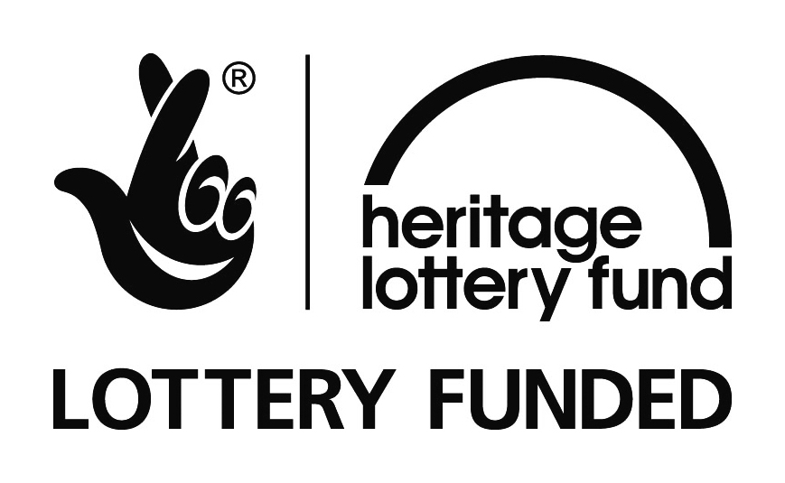

‘UNDERPASSES – CONNECTING PEOPLE, CONNECTING PLACES’ project.

On the Verge celebrates a grant of £85,600 from Heritage Lottery Fund for this project in Milton Keynes.
On the Verge, a local community interest company, has received a Heritage Lottery Fund (HLF) ‘Our Heritage’¹ grant for the ‘Underpasses – Connecting people, Connecting Places’ project in Milton Keynes, it was announced today. On the Verge and its partners MK Council, The Parks Trust MK and the MK City Discovery Centre, are delivering this exciting project with funding from the Heritage Lottery Fund (HLF), the MK Community Foundation, and MK Council.
Underpasses-Connecting People, Connecting Places will engage local people and communities in four estates around the central area of Milton Keynes - Fishermead, Oldbrook, Conniburrow and Downs Barn - in creative activities. These will be led by local artists and heritage organisations to explore the town’s history and ‘New Town’ heritage, design features and its unique system of underpasses. This year long project, ending early 2017 to tie into the MK50 anniversary celebrations, is a great opportunity to connect people to their shared MK heritage and help unify diverse local communities.
The activities and consultation will lead to commissioning of heritage inspired artwork and interpretation panels to transform three underpasses, creating attractive and safer surroundings for residents and visitors to enjoy, and highlighting the role the underpasses have in the urban design of Milton Keynes.
The programme of workshops, school sessions and activities exploring local heritage are led by Milton Keynes artists and are designed to allow local people to learn about and familiarise themselves with MK’s history and ‘New Town’ heritage.
All this research, artistic responses and local reminiscences will be transformed into two publications for children on MK’s ‘New Town’ history; there will also be an exhibition, heritage trail and an App.
QUOTES
Commenting on the award, Myriam Metcalf, OTV Director said: “On the Verge is incredibly excited about being awarded the ‘Our Heritage Grant’, which has enabled us to run this special project. MK is such a unique place that its 50-year (and beyond) history deserves to be explored and celebrated. We are looking forward to capturing the voices of today’s communities and looking to the past and sharing our findings in a creative way. The ‘Underpasses – Connecting people, Connecting places’ project will revive, improve and enhance selected underpasses, a key design feature of MK creating more attractive and safer surroundings for residents and visitors.”
Stuart McLeod, Head of the Heritage Lottery Fund, South East, said: “Our Heritage is a wonderful opportunity for communities to delve into their local heritage and we are delighted to be able to offer this grant so that On the Verge’s ‘Underpasses – Connecting people, Connecting places’ project can embark on a real journey of discovery. Heritage means such different things to different people, and HLF’s funding offers a wealth of opportunities for groups to explore and celebrate what’s important to them in their area.”
Shane Downer, Heritage Development Officer at Milton Keynes Council states: “MK Council is pleased to support On The Verge’s innovative project helping communities to explore the physical and social heritage related to the places in which they live, in a creative and artistic way. Working in and bringing together communities such as Downs Barn, Conniburrow, Fishermead and Oldbrook helps people understand the significance of MK’ s New Town origins and settlements.”
Henk van Aswegen, Director of the Milton Keynes City Discovery Centre said: “CDC are thrilled to be involved in the Underpasses project, which will help local people understand and appreciate their own local heritage and history within the larger context of Milton Keynes as a New Town and City.”

Rob Riekie Landscape and Operations Director with the Parks Trust has said:
“The Parks Trust are delighted that On the Verge has been successful with its HLF application and look forward to such areas as the CMK entrance into Campbell Park being brought to life. We are also happy to actively participle in the project by re-modelling sections of landscape to help showcase some of the art installations.”

ENDS

Notes to editors

About On the Verge
OTV (CIC) was established in 2007, to work with communities around the central area of Milton Keynes, to mark Gateways to the estates and improve their built environment and pride of place.
Our Heritage
¹Our Heritage is for any not-for-profit group wanting to explore their community’s heritage. With a commitment from HLF of £3m each year, Our Heritage grants between £10,000 to £100,000 are available and can help you protect and share the heritage you care about. Your project could focus on anything from personal memories and cultural traditions to archaeological sites, museum collections and rare wildlife.
Heritage Lottery Found - From the archaeology under our feet to the historic parks and buildings we love, from precious memories and collections to rare wildlife, we use National Lottery players' money to help people across the UK explore, enjoy and protect the heritage they care about. www.hlf.org.uk.
For further information, images and interviews, please contact:
Myriam Metcalf. OTV Project Director on otv@ontheverge.org.uk
http://www.ontheverge.org.uk/the-underpasses-project.html
Supporting information
The project was made possible by funding from:
Heritage Lottery Fund, Milton Keynes Council and Milton Keynes Community Foundation.
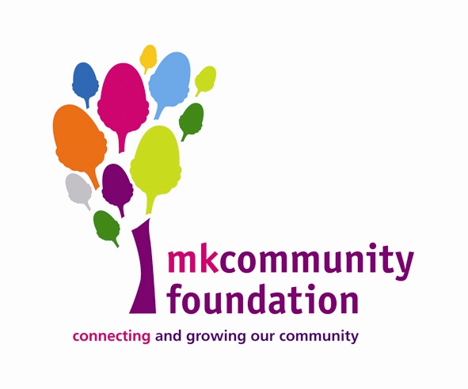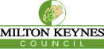

And Kind support is acknowledged from our project delivery partners:
The Parks Trust MK, MK City Discovery Centre and MK Council
Underpasses project sites:
Conniburrow and Downs Barn underpass, Fishermead and Oldbrook underbridge and Central
Milton Keynes and Campbell Park underpass.

