‘Underpasses - Connecting People, Connecting Places’ project.

MK is known to outsiders as the city of roundabouts and concrete cows. But insiders know our real identity is more complex, more textured... In 2017, Milton Keynes will celebrate its 50th anniversary, and Underpasses - connecting people, connecting places project will be right at the heart of that celebration.
It is a project that will transform three city underpasses from dark no-go zones into an artistic canvas. Public art will highlight some of MK's original estates, and their local communities, residents, and schools will participate.
The project is created and managed by On the Verge and has won major funding of £85,600 grant from the Heritage Lottery Fund.
Local people on Fishermead, Oldbrook, Conniburrow and Downs Barn will have the opportunity to engage with their heritage right on their doorstep in a totally new and exciting way, through taking part in a programme of heritage inspired workshops. There will be books about our new town heritage available to local school children and they will be taking part in their own workshop sessions, delivered with partner organisation the MK City Discovery Centre. Henk van Aswegen, Director of the Discovery Centre said “we are thrilled to be involved in the Underpasses project - it will help local people understand and appreciate their own local heritage and history within the larger context of Milton Keynes as a New Town and City.”
The project will culminate in the commissioning of exciting new artworks for the underpasses, to be opened in January 2017; these art pieces will take ideas and inspiration directly from local people on the estates involved.
With these activities and its rich community collaboration, On the Verge and Underpasses aims to connect residents with the unique heritage of the 'New Town' that is MK, raising awareness and helping to preserve its uniqueness for the future.
Underpasses - connecting people, connecting places is to be run in partnership with MK Council, the Parks Trust and the MK City Discovery Centre and Funding from HLF, MK Community Foundation and MK Council.

For further information, images and interviews, please contact:
Myriam Metcalf. OTV Project Director on mm@ontheverge.org.uk
http://www.ontheverge.org.uk/the-underpasses-project.html
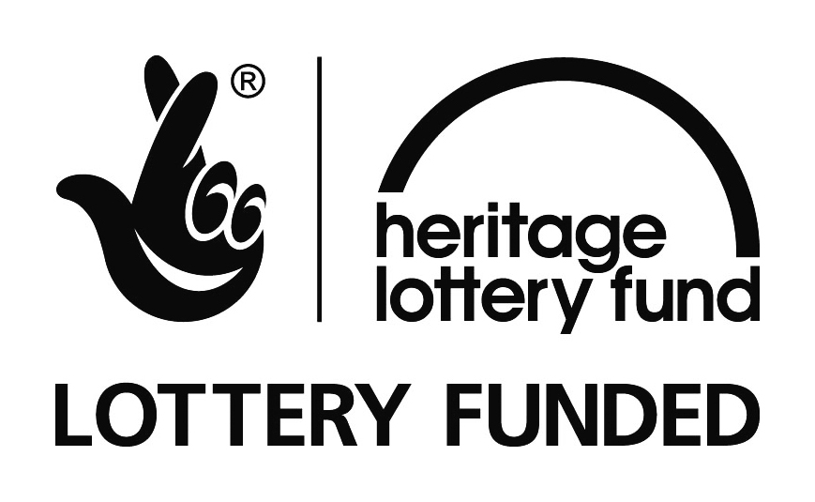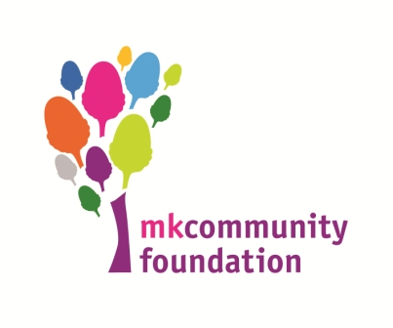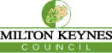

STATEMENTS

Stuart McLeod, Head of the Heritage Lottery Fund, South East, said: “Our Heritage is a wonderful opportunity for communities to delve into their local heritage and we are delighted to be able to offer this grant so that On the Verge’s ‘Underpasses – Connecting people, Connecting places’ project can embark on a real journey of discovery. Heritage means such different things to different people, and HLF’s funding offers a wealth of opportunities for groups to explore and celebrate what’s important to them in their area.”
Shane Downer, Heritage Development Officer at Milton Keynes Council states: “MK Council is pleased to support On The Verge’s innovative project helping communities to explore the physical and social heritage related to the places in which they live, in a creative and artistic way. Working in and bringing together communities such as Downs Barn, Conniburrow, Fishermead and Oldbrook helps people understand the significance of MK’ s New Town origins and settlements.”
Rob Riekie Landscape and Operations Director with the Parks Trust has said:
“The Parks Trust are delighted that On the Verge has been successful with its HLF application and look forward to such areas as the CMK entrance into Campbell Park being brought to life. We are also happy to actively participle in the project by re-modelling sections of landscape to help showcase some of the art installations.”
Commenting on the award, Myriam Metcalf, On the Verge Director said: “OTV is incredibly excited about being awarded the ‘Our Heritage Grant’, which has enabled us to run this special project. MK is such a unique place that its 50-year (and beyond) history deserves to be explored and celebrated. We are looking forward to capturing the voices of today’s communities and looking to the past and sharing our findings in a creative way. The ‘Underpasses – Connecting people, Connecting places’ project will revive, improve and enhance selected underpasses, a key design feature of MK creating more attractive and safer surroundings for residents and visitors.”

