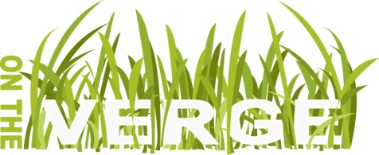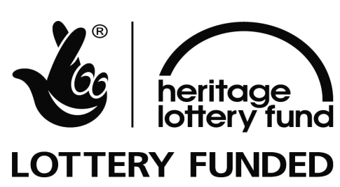
Release Date 15.8.16
On the Verge - ‘Underpasses - connecting people, connecting places’ project
Artist-led workshops launch ‘Underpass’ project within Conniburrow and Downs Barn.

Artist collective RARA, appointed by On The Verge, will be delivering the first community workshops look to reimage the underpass between Conniburrow and Downs Barn next to Marlborough Street. A programme of community events leading up to and informing the development of artworks for the underpasses will be taking place on the 23rd, 24th, 30th and 31st August at Conniburrow Community Centre.

RARA are looking for pioneering local residents to help create a performance based on their stories of moving to Milton Keynes. Over 4 workshops they will be creating words, actions and objects for an event that will accompany an art installation in the underpass between Conniburrow and Downs Barn. The workshops will be taking place between 11.00am-2.00pm over the four days.

No experience is necessary, all the workshops are free and a delicious lunch will be provided. If you want to join RARA over the four workshops to help develop the event and set your creativity free, either come along on the 23rd August at 11am to find out more or email Alex on parry.alexandra@gmail.com.

RARA, which stands for The Redundant Architects Recreation Association (RARA), will be working with communities based on Conniburrow and Downs Barn. Through their practice, they collaborate on a broad spectrum of works with a commitment to bringing people together through the creative processes of design and making. More information on previous projects and members of the group can be found at: www.r-a-r-a.com.

If you want to find out more about the artist-led events taking place in your area please look at the On The Verge website www.ontheverge.org.uk
or follow us on:
Facebook: @OnTheVergeMK
Twitter: @OnTheVergeMK

END
Notes to Editors
On the Verge and its partners MK Council, The Parks Trust MK and the MK City Discovery Centre, are delivering the yearlong ‘Underpasses’ project with funding from the Heritage Lottery Fund (HLF), the MK Community Foundation and MK Council. On the Verge is a Community Interest Company.
On the Verge has been awarded an ‘Our Heritage’ grant from the Heritage Lottery Fund towards the ‘Underpasses connecting people, connecting places’, which will see a series of heritage and cultural events taking place in 4 communities in Milton Keynes designed to explore its heritage and unique system of underpasses. On the Verge will be working with partners and artists to deliver a series of community engagement events to uncover local history, collecting artistic responses and oral histories. Artwork for two underpasses, a heritage trail and series of exhibitions and publications will be created through the project, culminating in a celebration event next year marking Milton Keynes’ 50th Anniversary.
For further information images and interviews please contact either
Myriam Metcalf – Project Director, On the Verge mm@ontheverge.org.uk
Clare Cleary – Project Manager, On the Verge. cc@ontheverge.org.uk
On The Verge website: http://www.ontheverge.org.uk

The Underpasses project is supported by: The Heritage Lottery Fund, Milton Keynes Community Foundation, and Milton Keynes Council and delivered in partnership with The Parks Trust MK, MK City Discovery Centre, and MK Council
